IRDAI Cyber Compliance for Log360
Automate IRDAI Cyber compliance and fortify cybersecurity resilience for financial institutions.
Region: India | Type: Financial Services, Incident Management, Operational Resilience | Category: Compliance | Pricing: Free

Overview
The IRDAI Cyber compliance extension in Log360 helps organizations meet IRDAI Information and Cyber Security Guidelines 2023, issued by the Insurance Regulatory and Development Authority of India for all insurers and insurance intermediaries by providing centralized log management, 180-day log retention, real-time threat detection, and audit reporting. The platform supports IRDAI Cyber requirements for access control, asset management, data classification, cryptographic controls, network security, 6-hour incident reporting, continuous monitoring, business continuity, and third-party risk management.
For Information Security Governance and Risk Management, Log360 monitors policy changes, GPO enforcement, OU management, and user auditing to provide governance evidence and support risk reporting to the board. To address Access Control and Identity Management, the platform monitors logon events, failed authentication, MFA activities, and user management changes across Windows, Unix, AD, and network devices to enforce identity controls. The extension also supports Asset Management and Data Classification by providing capabilities that tracks Windows program inventory, computer auditing reports, USB device connections, printer usage, and file changes to support asset lifecycle management and classification compliance.

Key Features
- Cryptographic Controls and Data Protection: Log360 detects registry modifications, unauthorized file access, removable media activity, and DLP events to identify data leakage or bypassing of encryption controls in insurer environments.
- Network Security and Boundary Protection: Log360 monitors network device rules, firewall policy changes, security events, attack alerts, and Windows firewall logs to ensure network boundaries remain secure.
- Incident Management and 6-Hour CERT-In Reporting: Log360 aggregates threat detection alerts, antivirus reports, system event logs, and network attack data to enable rapid incident triage and evidence collection for regulatory reporting.
- Monitoring, Logging, and 180-Day Log Retention: Log360 provides persistent log collection across Windows event logs, system events, process tracking, database audit logs, and application servers to meet the continuous monitoring and log retention mandate.
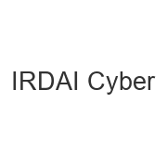
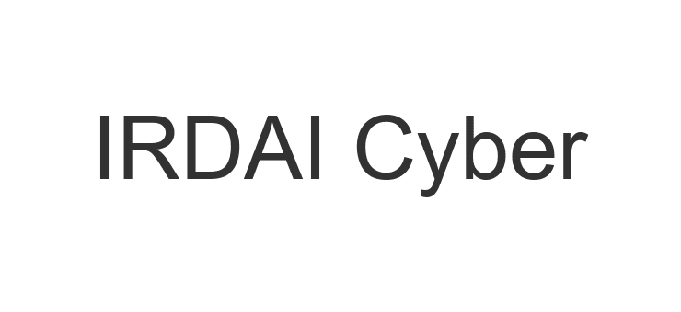
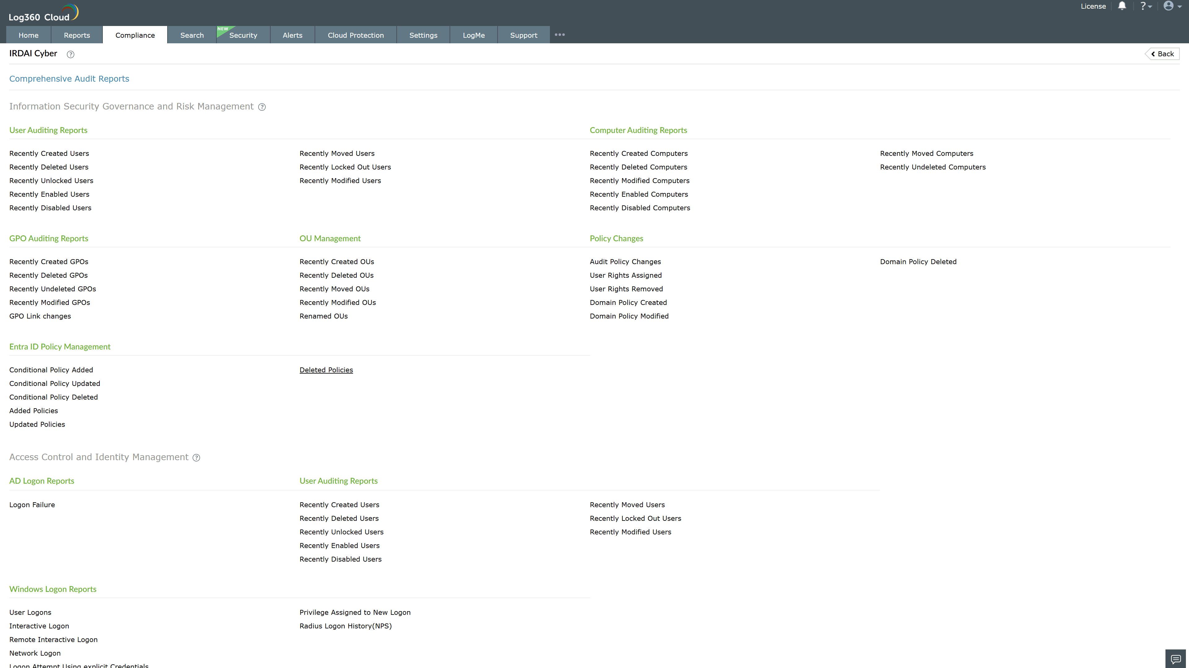
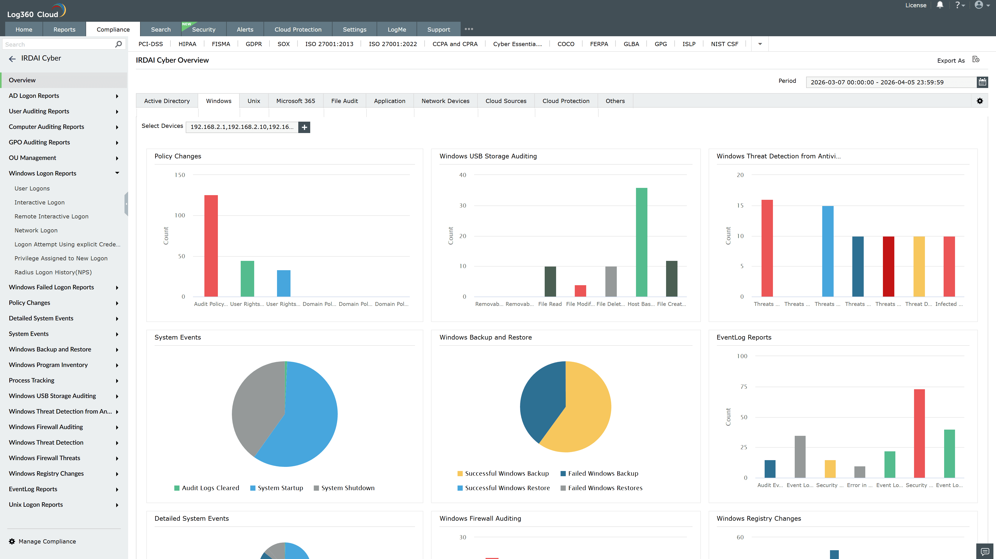
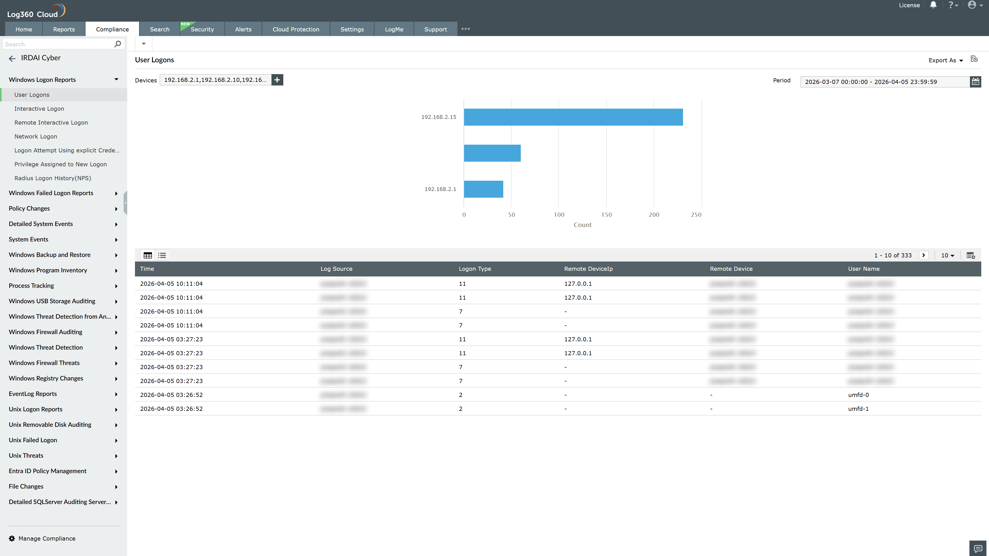
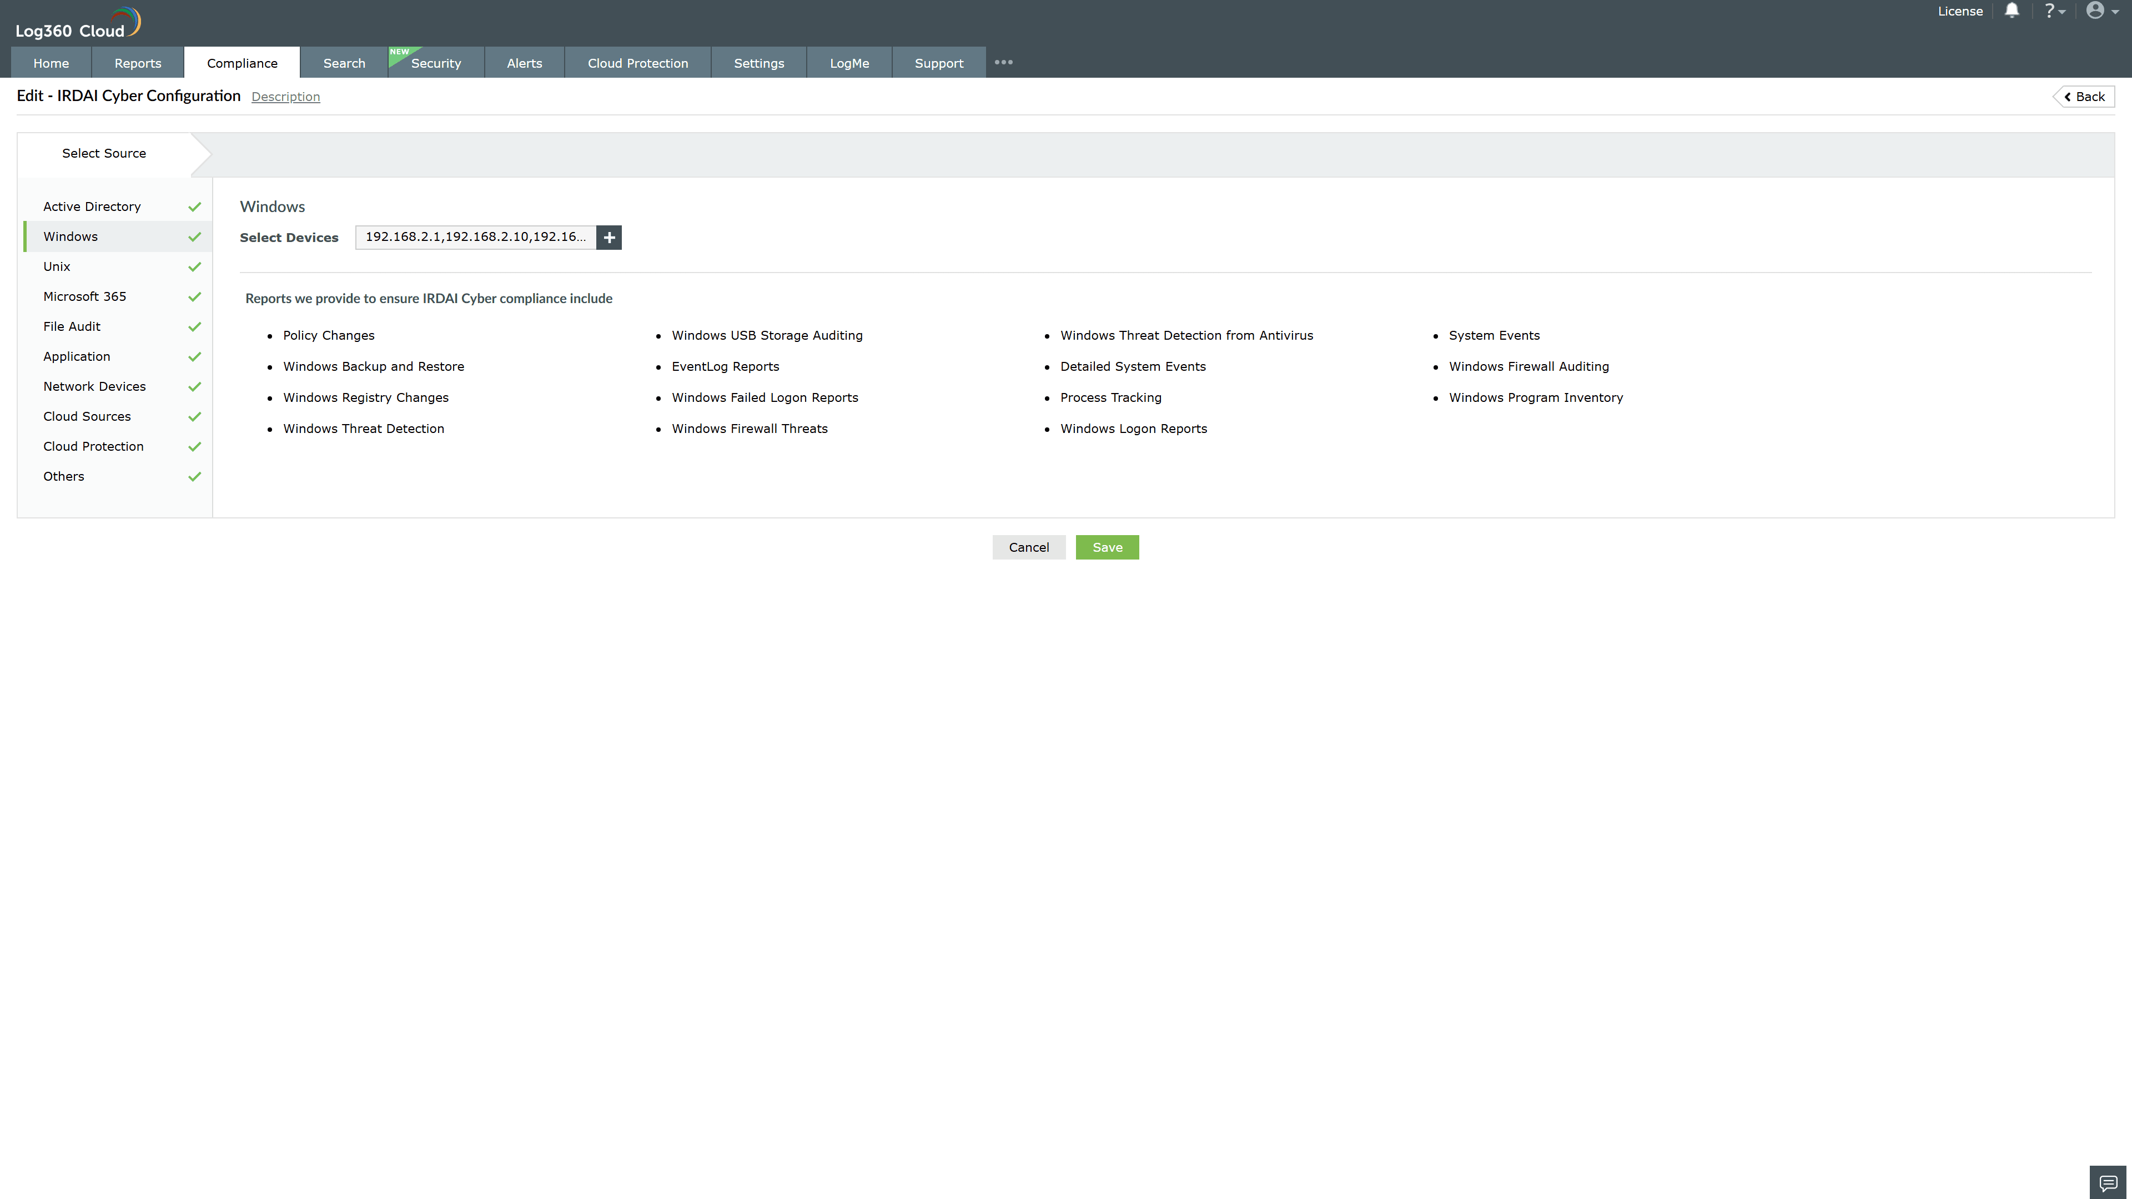
Valid Submission : Yes
Supported Editions : Free, Basic, Standard, Professional, MSSP
Help Document : https://www.manageengine.com/log-management/help/integrations/compliance-extensions.html
Help Video : Not provided
Tags : Log360, Compliance, Privacy monitoring, Data privacy, Regulatory compliance
Supported DCs : US, IN, JP, CA, AU, UK and EU
Privacy Policy:
Terms of Service:
Release Notes:
Predefined reports for the IRDAI Cyber.

